Dear Districts,
Thank you for trusting in the Educational Service Center of Northeast Ohio Educational Audiology team for your needs. I apologize in advance for the lengthy document but we wanted to provide you with some important considerations as schools make plans for the fall.
On July 2, 2020, Governor DeWine held his daily press conference regarding reset and restart for schools. During this press conference he summarized key points that are included in the COVID-19 Health and Prevention Guidance for Ohio K-12 Schools. As educational audiologists, we understand that students with any degree of hearing loss will be challenged by the use of face coverings and physical distancing. With the released guidance, a balancing act of safety and health as well as accessibility will be important. These are the known challenges that will be present:
Masks and Hearing Loss:
- Muffled Speech
- Lack of visual/speechreading/emotional cues
- Peer interaction and masks can impact social and academic growth
Physical Distance and Hearing Loss
- Hearing aids, cochlear implants, and Bone anchored hearing devices do not amplify the further you are from the microphone
- Physics of sound indicates reduction of sound as we get further apart
- Increased level of sound when we raise voices from a distance and speak through a mask

Research under “normal” conditions demonstrates that the following populations are also at risk for decreased learning in poor acoustical environments. The addition of physical distancing and face coverings will amplify these acoustical environments as well as the learning challenges of the following student population.
- Students who are less than 15 years of age due to immature auditory brain development
- Students with ear infections
- Students with language and speech disorders
- Students identified and at risk for specific learning disabilities, including those with dyslexia
- Students who are identified as English learners
- Students with Auditory Processing Deficits
- Students identified as having a sensorineural and conductive hearing loss (bilateral and unilateral)
- Children with developmental delays
- Students identified as having Attention deficit disorder with or without hyperactivity

We understand each district is developing their own local level reopening plans. The educational audiologists are available to help consult with access to hearing and listening improvements while balancing the safety and health of students/staff. We know that there is no one perfect solution. We are in this with all of you and will strive to use local, state, and national networks to problem solve this novel situation.
Here are a few considerations that may be helpful as your district prepares. Please note that we do not endorse any product specifically. There are a lot of products that have sprung up due to the pandemic.

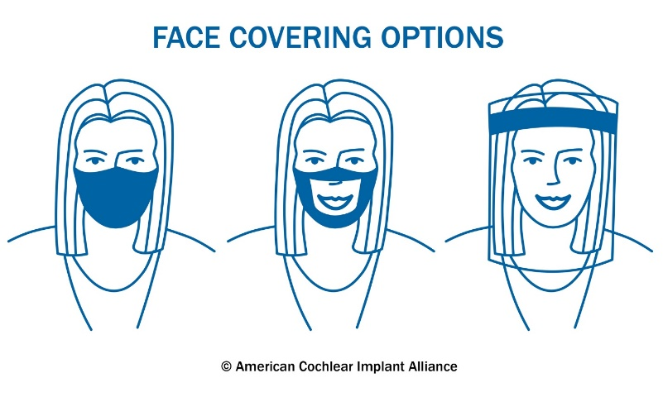

FACE SHIELDS AS AN OPTION FOR IMPROVED VISBILITY

The COVID-19 Health and Prevention Guidance for Ohio K-12 Schools Indicates the consideration of Face Shields as an option for faces coverings (https://coronavirus.ohio.gov/static/responsible/schools/K-12-Schools-Guidance.pdf page 14)
“Face shields that wrap around the face and extend below the chin can be considered as an alternative where cloth face coverings would hinder the learning process. Some situations where face shields would be useful include:
• When interacting with students, such as those with disabilities, where communication could be impacted
• When interacting with English-language learners or when teaching a foreign language.
• Settings where cloth masks might present a safety hazard (i.e. science labs)
• For individuals who have difficulty wearing a cloth face covering”

CLEAR MASKS (DIY AND COMMERCIAL)

Another considering for face coverings that can help with visibility are clear face masks. I have been working with colleagues to “rate” the multiple choices that are available online and DIY. Here is a link to a summary of different products that are available. https://tinachildress.wordpress.com/2020/06/. These will be updated as new information on products becomes rated. There are also some “disposable” options that can also be considered. These can be disinfected and reused, however, I am not sure how long they would hold up. https://www.oaktreeproducts.com/clearmask-transparent-face-mask-24-box-cm24.

DESK SHIELDS

For students who are sitting at their desk and need to be protected but may not wear a shield or mask, this might be a consideration to help with visibility. This also might be a consideration for small group instruction, speech-language therapy groups, etc. This might be a solution to consider for situations when shields and masks are not able to be used. All of the shields are sold in bundles of 24 and the below prices do not include the shipping and handling:
Small – 14” ideal for elementary students and smaller desks $384/bundle
Medium – 18” sized for middle school/ high school students and desks $528/bundle
Large – 24” ideal for college students and spaces needing higher coverage $732/bundle
All sizes are 22” wide and 16” deep
https://assets.website-files.com/5e98b85507757a5304dc1348/5eeb7222feed5e424ebf5614_Desk%20Shields%201.pdf
Any interested schools should contact Janelle Wagner at jwagner@mys3tech.com or 330.648.5408
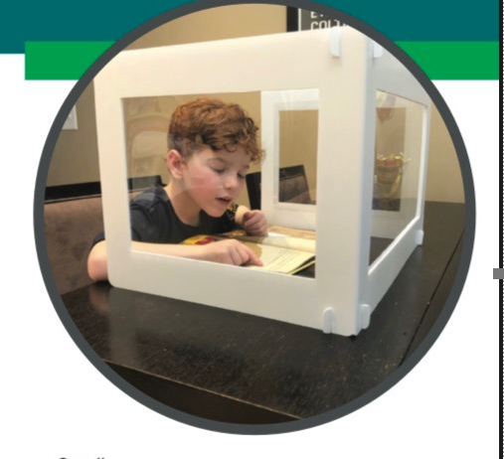

Improved Signal to Noise Ratio

The combination of physical distancing and face coverings will create more difficulties hearing and learning in the classroom. The following webinar reviews this information: https://info.lightspeed-tek.com/requestwebinarovercominglisteningbarriers.
Many classrooms are equipped with classroom amplification systems (soundfield). With masks and physical distancing, this is the time for our teachers to maximize the use of these systems. Some initial classroom based experimental trials have indicated that soundfield amplification improved the “masks and face shield” muffled speech. For students with personal hearing technology, this will be necessary for teachers and students to be using. If you are considering purchasing CADS systems, we can help with suggestions and connections.
We will also be in touch with providing support on cleaning and disinfecting shared amplification systems. Clorox wipes are too harsh on the technology.

The educational audiology team will also be available to problem solve additional situations that arise due to accessibility for in person, hybrid, and at home learning. Please do not hesitate to reach out now if you would like to consult prior to August. Dr. Ausperk and Dr. Cobler are available to schedule a Zoom or conference call to help brainstorm and help develop solutions for the 2020-2021 school year.

Thank you,

Ellen Cobler, Au.D., CCC/A
Lori Ausperk, Au.D., CCC/A
Educational Audiologists

